PROJECT 1.1

Simple Regression Analysis on Fuel Economy Data

Part 1 (R & Excel Analytics)

1. Introduction

You are provided with two datasets, “FE2010.csv” and “FE2011.csv”. You are required to work on “FE2010.csv” only for any kind of experiment. The datasets contain different estimates of fuel economy for passenger cars and trucks. For each vehicle, various characteristics are recorded such as the engine displacement or number of cylinders. Along with these values, laboratory measurements are made for the city and highway fuel economy (FE) of the car. Analyze the data on the relationship between fuel economy and engine displacement. The training data consists of model year 2010 data and the test set is comprised of cars from 2011 that were not in the 2010 data set.

You are required to build a Regression Model for fuel economy (FE), by choosing a single input variable which is the best suitable for predicting FE. You will use 2010 dataset for this purpose. All your work will be validated on 2011 dataset.

2. Objective
The project aims to perform Simple Regression Analysis on Fuel Economy Data.

3. Prerequisites
N/A

4. Associated Data Files
https://drive.google.com/file/d/0B3nTkXniPMACMUc0RVJXODhlUDA/view?usp=sharing

5. Problem Statement
Below are the points which your final submission should answer:
Use Excel and Functions
- Find the best input variable for predicting FE using suitable statistical test(s).

- Fit a Simple Linear Regression Model using the selected input variable. Use the formulas discussed in the class to calculate the coefficients.

- Observe the relationship between the Input variable and FE and analyse if they maintain a linear relationship using a suitable chart in Excel.

- Use appropriate transformation of input variable if the relation above is not linear. Build the Regression model after transformation. Please ask the course instructor for help in variable transformation, if you required so.

- Calculate the MAPE (Mean Absolute percentage Error) and R2 of the model. Implement the model on the test data and find out the test accuracy as well. The formula and small note for the error calculation are given at the end of the document.

- Use a random sampling method to divide the dataset in to 3 parts. Use rand() function.
A C A D G I L D Page 4

a. Take 2 parts for modeling and 1 part for testing at a time randomly.

b. Check the modeling Error statistics (as given in previous point 5) of the model and test on the 3rd part of the data for testing the error.

c. Iterate this process 3 time to cover all possible selection of 2 parts for modeling and the 3rd part for testing. There are 3 possible combination in this way. So you would end up with creating 3 models on three different dataset.

d. Calculate the average model accuracy (Use Error formulas from 5.) and average test accuracy. Judge if they are consistent and provide your comment on what you observe.

e. Compute the Beta coefficients by taking average of the three models.

f. Test the final Accuracy by implementing the model on 2011 dataset.

Use Excel Data Analysis tool
- Use Data Analysis feature of Excel to bypass the co-efficient calculation formulas and compute the Regression Model directly.

- You should be able to repeat all the points asked under “Use Excel” using Data Analysis tool. You may need to do the random sampling separately here as well.

APPROACH

FE 2010 data consists of many input variables and a response variable given as Fuel efficiency collected based on the various vehicle input data. For all these variable correlation coefficient is found in excel and is found as given below


EngDispl -0.79

Numcyl -0.74

NumGears -0.21

TransLockup -0.27

TransCreeperGear -0.07

IntakeValvePerCyl 0.28

ExhaustValvesPerCyl 0.34

VarValveTiming 0.12

VarValveLift 0.10

Based on the above findings EngDispl and Numcyl are having very good correlation and as per the problem statement we have plotted these variable with suitable charting in Excel
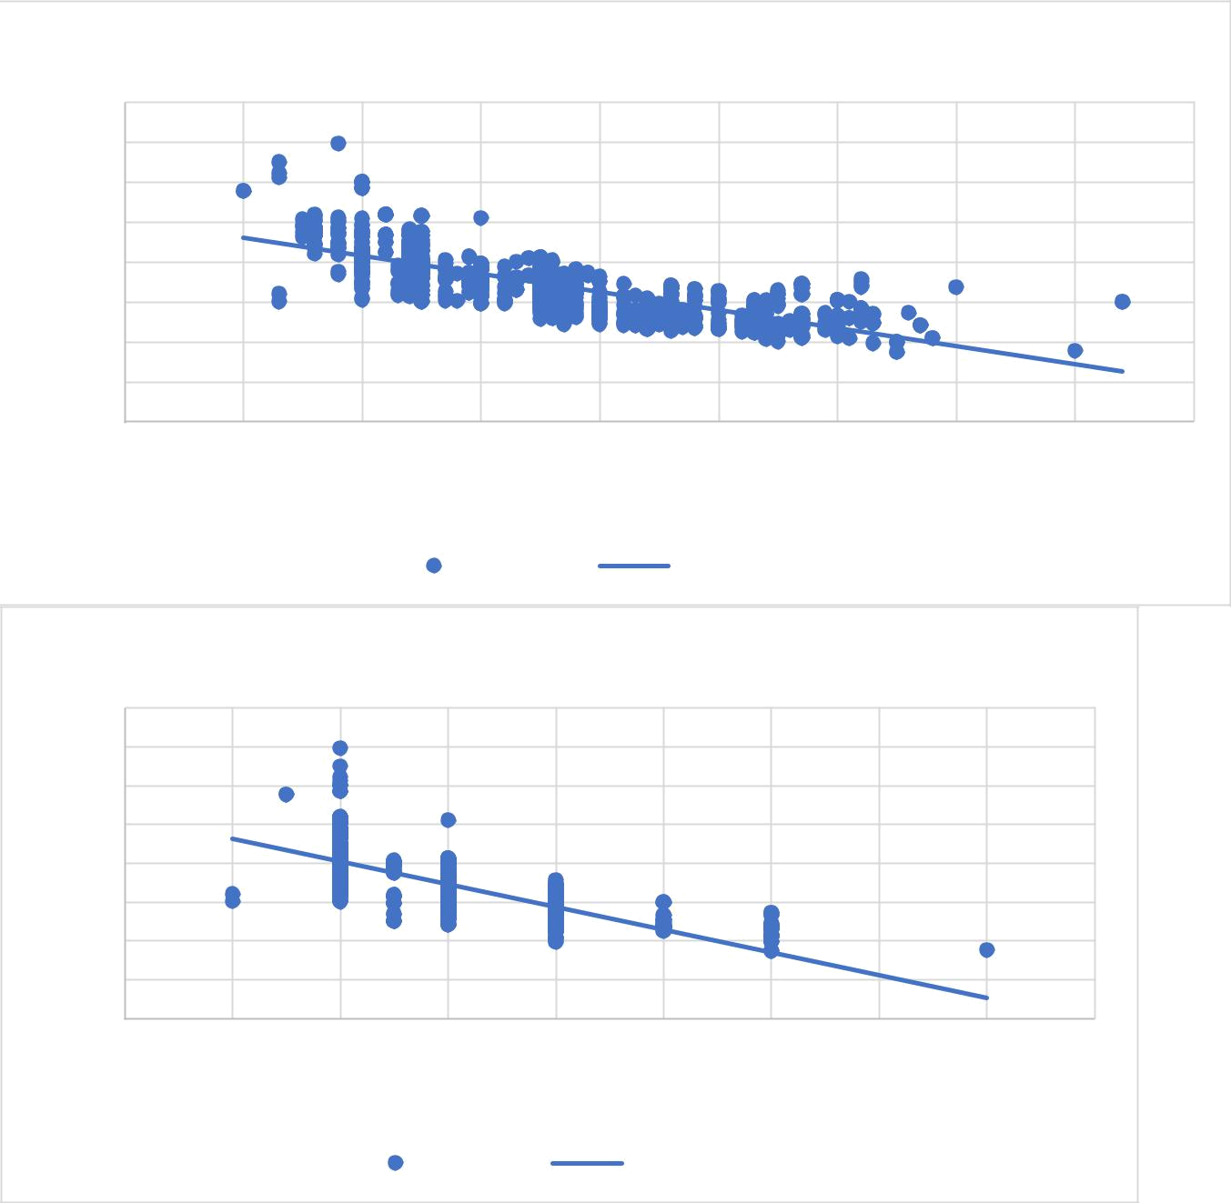
FE vs # EngDisp

Fuel Efficiency

80
70
60 | y = -4.5209x + 50.563
50 | y = -4.5209x + 50.563
50 | R² = 0.62
40
30
20
10
0

0 | 1 | 2 | 3 | 4 | 5 | 6 | 7 | 8 | 9
 |  |  |  |  | EngDispl
 |  |  | EngDispl |  | Linear (EngDispl)

FE vs # of Cylinders

Fuel Efficiency

80
70
60
50 | y = -2.9203x + 52.144
50 | R² = 0.5479
40 | R² = 0.5479
30
20
10
0

0 | 2 | 4 | 6 | 8 | 10 | 12 | 14 | 16 | 18
 |  |  |  | # of Cylinders
 |  |  | NumCyl |  | Linear (NumCyl)

Based on this graph these two input variables appear to be linear. Further the whole data is analysed in R to find the Linear relationship

Use appropriate transformation of input variable if the relation above is not linear. Build the Regression model after transformation.
Please ask the course instructor for help in variable transformation, if you required so.
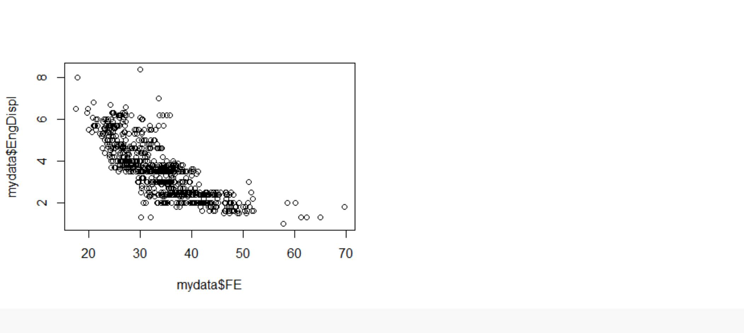

cor(mydata$FE,mydata$EngDispl)

## [1] -0.7873938

cor(mydata$FE,mydata$VarValveLift)

## [1] 0.09621127

cor(mydata$FE,mydata$VarValveTiming)

## [1] 0.1249528

cor(mydata$FE,mydata$ExhaustValvesPerCyl)

## [1] 0.3356529

cor(mydata$FE,mydata$IntakeValvePerCyl)

## [1] 0.280344

cor(mydata$FE,mydata$TransCreeperGear)

## [1] -0.06962168

cor(mydata$FE,mydata$TransLockup)

## [1] -0.2719389

cor(mydata$FE,mydata$NumGears)

## [1] -0.2112849

cor(mydata$FE,mydata$NumCyl)

## [1] -0.740218

mod=lm(mydata$FE~mydata$EngDispl)

mod

##

- Call:

- lm(formula = mydata$FE ~ mydata$EngDispl)

##
## Coefficients:
## | (Intercept) |  |  | mydata$EngDispl
## |  | 50.563 |  |  | -4.521
summary(mod)
##
## Call:
## lm(formula = mydata$FE ~ mydata$EngDispl)
##
## Residuals:
## | Min |  | 1Q | Median | 3Q | Max
## -14.486 |  | -3.192 |  | -0.365 | 2.671 27.215
##
## Coefficients:
## |  |  |  | Estimate Std. Error t value Pr(>|t|)
## (Intercept) |  |  |  | 50.5632 | 0.3985 | 126.89 | <2e-16 ***
## mydata$EngDispl |  |  |  | -4.5209 | 0.1065 | -42.46 | <2e-16 ***
## ---
## Signif. codes: |  |  |  | 0 '***' 0.001 '**' 0.01 '*' 0.05 '.' 0.1 ' ' 1

##

## Residual standard error: 4.624 on 1105 degrees of freedom

## Multiple R-squared: 0.62, Adjusted R-squared: 0.6196

## F-statistic: 1803 on 1 and 1105 DF, p-value: < 2.2e-16

#Assumption1 Linearity

plot(mydata$FE,mydata$error,xlab="FE",ylab="Residuals",main="Linearity")
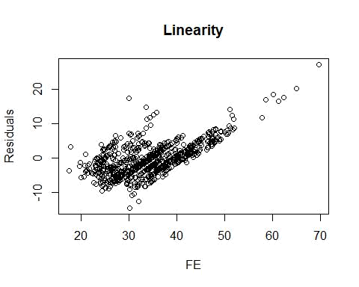

fit<-lm(FE~EngDispl+NumCyl+NumGears+TransLockup+TransCreeperGear+IntakeValvePerCyl+ExhaustValvesPerCyl+VarValveTimi

ng+VarValveLift,data=FE2010)

fit

##

- Call:
- lm(formula = FE ~ EngDispl + NumCyl + NumGears + TransLockup +
- TransCreeperGear + IntakeValvePerCyl + ExhaustValvesPerCyl +
- VarValveTiming + VarValveLift, data = FE2010)

##

## Coefficients:

## (Intercept) EngDispl NumCyl
## | 54.3472 | -3.8610 | -0.4888
## | NumGears | TransLockup | TransCreeperGear
## | -0.1725 | -1.4450 | -0.9138
## | IntakeValvePerCyl | ExhaustValvesPerCyl | VarValveTiming
## | -0.3737 | -1.1105 | 1.6870
## | VarValveLift
## | 0.6235

summary(fit)

##

## Call:

## lm(formula = FE ~ EngDispl + NumCyl + NumGears + TransLockup +

## | TransCreeperGear + IntakeValvePerCyl + ExhaustValvesPerCyl +
## | VarValveTiming + VarValveLift, data = FE2010)
##
## Residuals:
## | Min | 1Q | Median | 3Q | Max
## -17.1153 |  | -2.7142 | -0.3535 | 2.4191 25.6521
##
## Coefficients:
## |  |  | Estimate Std. Error t value Pr(>|t|)
## (Intercept) |  |  | 54.3472 | 1.0973 | 49.530 | < 2e-16 ***
## EngDispl |  |  | -3.8610 | 0.2805 | -13.765 | < 2e-16 ***
## NumCyl |  |  | -0.4888 | 0.1845 | -2.649 | 0.00819 **
## NumGears |  |  | -0.1725 | 0.1065 | -1.620 | 0.10555
## TransLockup |  |  | -1.4450 | 0.3000 | -4.817 1.66e-06 ***
## TransCreeperGear |  |  | -0.9138 | 0.6681 | -1.368 | 0.17167
## IntakeValvePerCyl |  |  | -0.3737 | 0.9892 | -0.378 | 0.70566
## ExhaustValvesPerCyl |  |  | -1.1105 | 0.9598 | -1.157 | 0.24752
## VarValveTiming |  |  | 1.6870 | 0.3796 | 4.444 9.71e-06 ***
## VarValveLift |  |  | 0.6235 | 0.3719 | 1.676 | 0.09393 .

## ---

## Signif. codes: 0 '***' 0.001 '**' 0.01 '*' 0.05 '.' 0.1 ' ' 1

##
- Residual standard error: 4.489 on 1097 degrees of freedom
- Multiple R-squared: 0.6445, Adjusted R-squared: 0.6415

- F-statistic: 220.9 on 9 and 1097 DF, p-value: < 2.2e-16

vif(fit)
## |  | EngDispl |  |  |  | NumCyl |  |  |  |  | NumGears
## |  | 7.363137 |  |  |  | 6.750388 |  |  |  | 1.214238
## |  | TransLockup |  |  |  | TransCreeperGear |  |  |  | IntakeValvePerCyl
## |  | 1.075253 |  |  |  | 1.137623 |  |  |  | 6.693985
## ExhaustValvesPerCyl |  |  |  |  |  | VarValveTiming |  |  |  |  | VarValveLift
## |  | 7.073284 |  |  |  | 1.153276 |  |  |  | 1.057688
vif(fit)>5
## |  |  | EngDispl |  |  |  | NumCyl |  |  |  | NumGears
## |  |  |  | TRUE |  |  |  | TRUE |  |  | FALSE
## |  | TransLockup |  |  |  | TransCreeperGear |  |  |  |  | IntakeValvePerCyl
## |  |  | FALSE |  |  |  | FALSE |  |  |  |  | TRUE
## | ExhaustValvesPerCyl |  |  |  |  | VarValveTiming |  |  |  |  | VarValveLift
## |  |  |  | TRUE |  |  | FALSE |  |  |  | FALSE

Based on the above Vif(fit)>5 the yellow highlighter like EngDispl, Numcyl etc are better linearity and fit for further analysis in Excel

Excel Analysis

Calculate the MAPE (Mean Absolute percentage Error) and R2 of the model. Implement the model on the test data and find out the test accuracy as well.

The formula and small note for the error calculation are given at the end of the document.
One example (small part of excel data)for the data Numcyl is given below to show how we calculate MAPE values

For the entire 2010 data we have calculated Beta coefficient and the intercept from the scatter plot to predict the Fuel efficiency as given below in predicted Y

Beta coefficient calculation for 2010
 |  | FE | Engdisp | Numcyl | NumGears | TransLockup | TransCreeperGear | IntakeValvePerCyl | ExhaustValvesPerCyl | VarVa
 | std dev | 7.498033 | 1.305905 | 1.900575 | 1.396624 | 0.466603 | 0.215506 | 0.353046 | 0.374035 | 0.381
 | Variance (VARA(B3:B1109)) | 56.22049 | 1.705388 | 3.60892 | 1.948796 | 0.217522 | 0.046401 | 0.124529 | 0.139776 | 0.145
 | Covariance
 | (COVAR(A3:A1109,B3:B1109) |  | -7.70297 | -10.539 | -2.21056 | -0.95055 | -0.1124 | 0.741443 | 0.940497 | 0.357
 | Beta coeff by cal
 | Formula=(covariance/variance) |  | -4.51685 | -2.92026 | -1.13432 | -4.36989 | -2.42232 | 5.953976 | 6.728613 | 2.453
 | Beta coeff by graph |  | (-)4.5209 | (-)2.9203


Excel Instructions:

There are four ways that you can calculate a Beta using Excel. The first

is to use the "=slope" formula. In this formula, the X variable series is the

return on the market and the Y variable series if the return on FE.

This gives:

-5.0180

A second alternative is to calculate the Beta directly as the covariance

between the two return series, divided by the variance of market returns.

Using the summary statistics at the bottom of the page, this gives:

-5.4164

A third method is to use the full regression procedure in Excel. Go to

"Tools" - "Data Analysis" - "Regression" and click OK. Again, enter the

market return series as the X variable and the HD return series as the

Y variable. When you click OK, you should get full regression output

similar to that shown in the worksheet labelled " FERegr Output".

Finally, you can create a regression Beta in Excel using the chart functions.

Remember that Beta is just the slope in a regression where EngDispl

are on the X axis and FUEL EFICENCY (FE are on the Y axis.

To create this type of graph, highlight the two columns of data, with market

returns on the left. After highlighting the return series, click on the chart

wizard icon (or choose "Insert" - "Chart"). Under chart types, select

"X-Y scatterplot" and click Next. Click Next twice more to get to step 4 of 4.

In step 4, select "as new sheet" and click finish. When the new chart

comes up, select the "Chart" tab at the top of the page, and then select

"Add Trendline". Select the "Options" tab, and click the buttons for

"display equation" and "display R square", then click OK. This should add

both a regression line and a regression equation to your chart. The results

should look similar to those shown in the worksheet labelled "FE Chart".

70
60 | EngDispl Beta coefficient Regression for a 2011
60 | random data
50
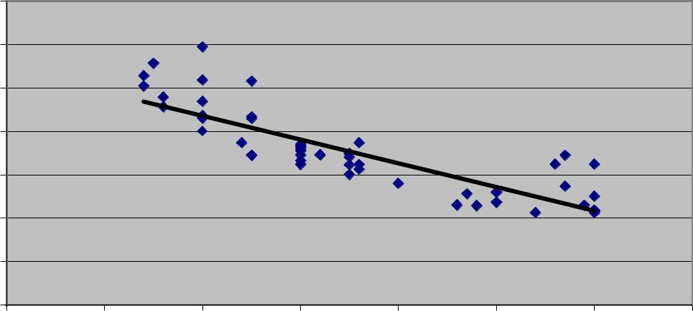

⁴⁰y = -5.462x + 54.429
30 R² = 0.7357

20

10

0

0 1 2 3 4 5 6 7

Based on the calculation of Beta coefficient as given above and with the intercept from the graph,
One example (small part of FE 2011 excel data)for the data Numcyl is given below to show how we calculate MAPE values

X | Y |  | Predicted Y
 |  |  | Predicted |  |  | Dis Y and their
NumCyl | FE |  | FE | Error |  | mean | Square F
12 |  | 22.9258 | 17.1004 | 5.8254 | 33.93529 | -11.80486408 | 139.3548
8 |  | 26.7678 | 28.7816 | -2.0138 | 4.05539 | -7.962864082 | 63.4072
8 |  | 24.301 | 28.7816 | -4.4806 | 20.07578 | -10.42966408 | 108.7779
10 |  | 24.3325 | 22.941 | 1.3915 | 1.936272 | -10.39816408 | 108.1218
10 |  | 23.0667 | 22.941 | 0.1257 | 0.0158 | -11.66396408 | 136.0481
6 |  | 32.8579 | 34.6222 | -1.7643 | 3.112754 | -1.872764082 | 3.507245
4 |  | 52.2 | 40.4628 | 11.7372 | 137.7619 | 17.46933592 | 305.1777
4 |  | 55.6446 | 40.4628 | 15.1818 | 230.4871 | 20.91393592 | 437.3927
8 |  | 26 | 28.7816 | -2.7816 | 7.737299 | -8.730664082 | 76.2245
12 |  | 25 | 17.1004 | 7.8996 | 62.40368 | -9.730664082 | 94.68582
8 |  | 26.8 | 28.7816 | -1.9816 | 3.926739 | -7.930664082 | 62.89543
No of rows is calculate in n = COUNT(D3:D247) MSE is calculated (L248/C250)( Error square/n)

RMSE is the square root of MSE (SQRT(C253)

 |  | ABS values of
 |  | error/Actual
Abs v of error | Error 2 | value
5.8254 | 33.93529 | 0.254098
2.0138 | 4.05539 | 0.075232
4.4806 | 20.07578 | 0.184379
1.3915 | 1.936272 | 0.057187
0.1257 | 0.0158 | 0.005449
1.7643 | 3.112754 | 0.053695
11.7372 | 137.7619 | 0.224851
15.1818 | 230.4871 | 0.272835
2.7816 | 7.737299 | 0.106985
7.8996 | 62.40368 | 0.315984
1.9816 | 3.926739 | 0.073940

MAPE is calculated ((M248/C250)*100) M248 = sum of (ABS values of error/Actual value) and C 250 is the no row count ie 245

Given below is calculated from the prediction of FE using the input variable Numcyl beta coefficient and intercept. Similarly we have calculated the same with EngDispl variable

n 245

MAD 4.470793061

 | MSE |  |  |  | 34.67015725
 | RMSE |  |  |  | 5.888136993
 |  |  |  |  |  |  | Mean absolute percentage
 | MAPE |  |  |  | 13.37649118 |  | error
 |  |  |  |  |  |  | 1 - (SUM(E3:E247)) sum of all
 |  |  |  |  |  |  | values of Error square) /sum of
 |  |  |  |  |  |  | Square of Dis Y and their mean
 |  |  |  |  |  |  | would provide the R square by
 |  |  |  |  |  |  | calculation.
 | 0.589277463 |  |  | R 2 by calculation |  |  | 1-(E248/G248) | by graph 0.5479

Use a random sampling method to divide the dataset in to 3 parts. Use rand() function.

FE 2011 data is divided into 3 sets using random function in Excel like Rand() , Rand1,Rand2 and Rand3 is used for testing based on these two data, Hence Fe2011 data is divided into 3 equal parts approximately 82 values in each
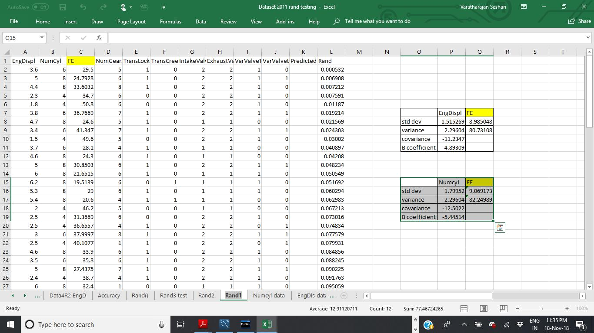
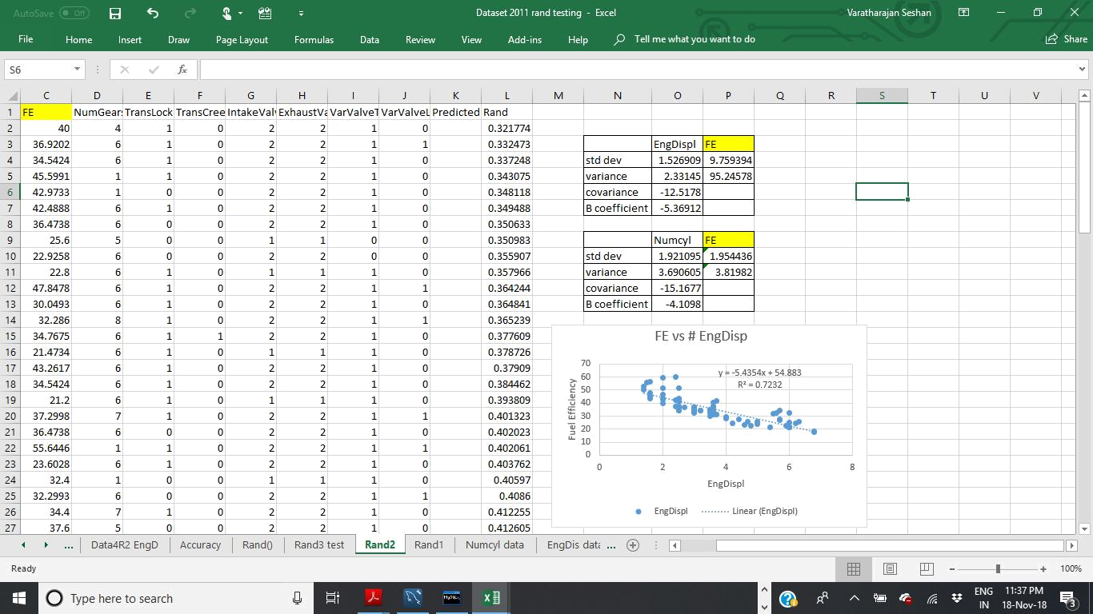
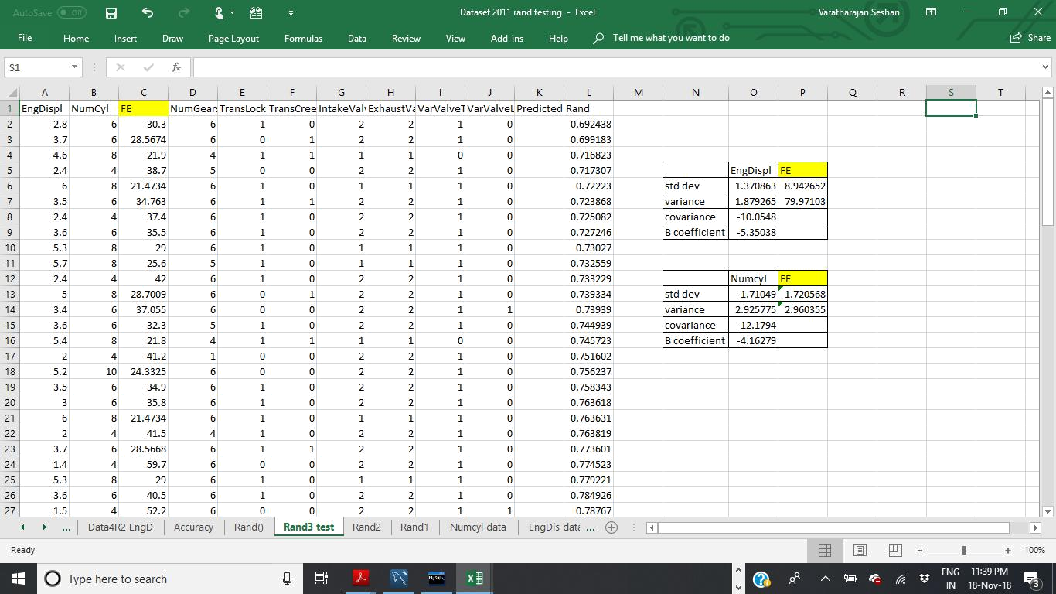

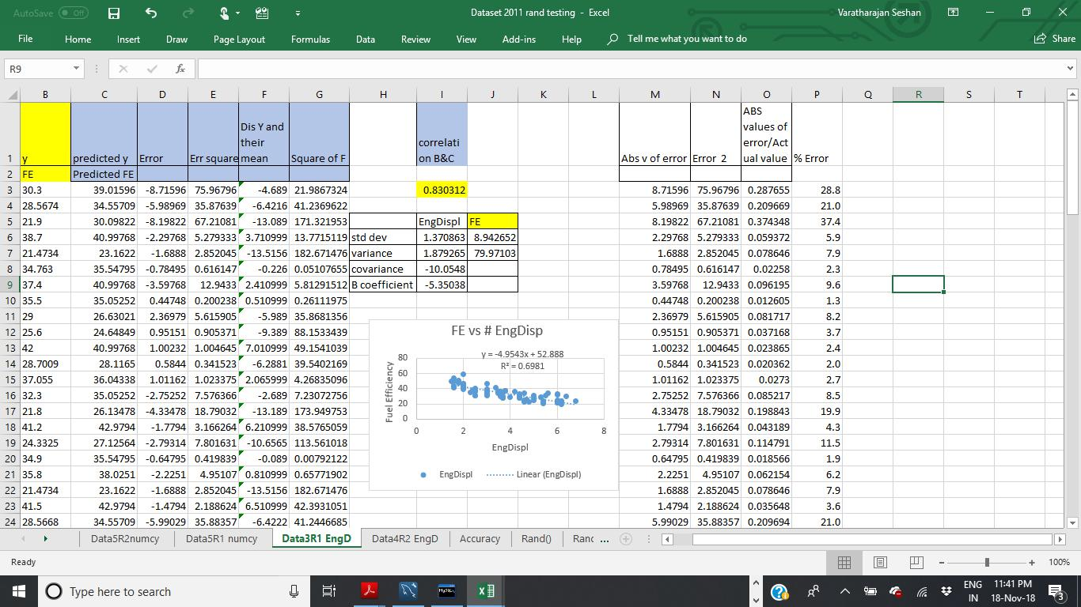

n | 82

MAD  3.870526098

MSE 25.37700219

Prediction of FE in Rand3

test case done and
calculated the following

Average % Error | 11.5

Average Test Accuracy | 88.5

RMSE | 5.03755915
 |  |  | Mean absolute percentage
MAPE | 11.50998577 |  | error
R square by calculation |  |  | 0.678755
As per plot | 0.6981

In the similar way we have predicted using Rand2 Beta coefficient values of EngDispl values and Numcyl values

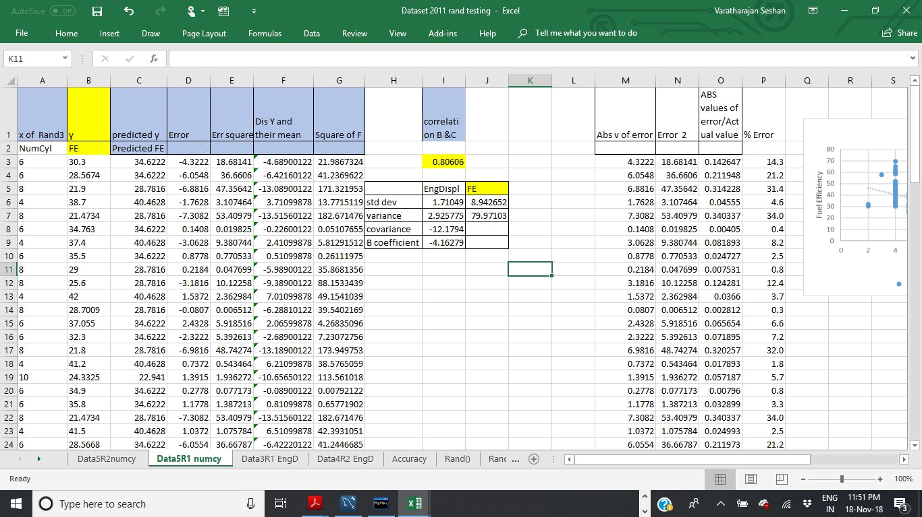

 | n | 82
MAD |  | 4.06664878
MSE |  | 32.66996772
RMSE |  | 5.715764841
 |  |  | Mean absolute percentage
MAPE |  | 11.8571359 | error

R square by calculation | 0.586434 |  | As per plot | 0.5479

a. Take 2 parts for modeling and 1 part for testing at a time randomly.

b. Check the modeling Error statistics (as given in previous point 5) of the model and test on the 3rd part of the data for testing the error.

c. Iterate this process 3 time to cover all possible selection of 2 parts for modeling and the 3rd part for testing. There are 3 possible combination in this way. So you would end up with creating 3 models on three different dataset.

d. Calculate the average model accuracy (Use Error formulas from 5.) and average test accuracy. Judge if they are consistent and provide your comment on what you observe.

e. Compute the Beta coefficients by taking average of the three models.

f. Test the final Accuracy by implementing the model on 2011 dataset.

For the requirement of iterations in the question the same is repeated with Rand 1 and Rand2 variables and the consolidate finding is given below
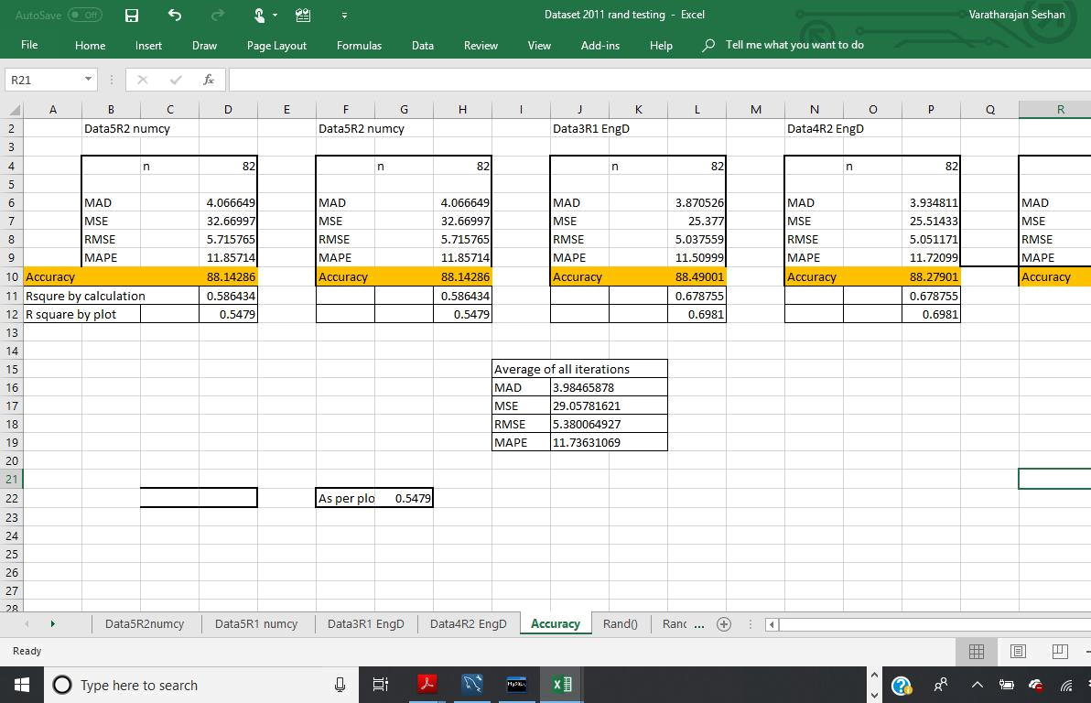

Based on the findings the MAPE values of all tests are found to be vey close though the test is done on various input variable and the accuracy is found to be around 88.3%

The average of the all the model of Engdispl Beta coefficient is given below and further the average Beta coefficient is applied and predicted the FE as given in the screenshot below. And the MAPE values and accuracy is calculated as per the requirement in the question(Test the final Accuracy by implementing

the model on 2011 dataset.) and the same is given below. Relevant excel sheets are attached separated in the submission,

Eng displ

-4.8939

-5.36912

-5.35080

-
Average 5.20460667

 |  |  |  |  | n |  |  |  |  | 245
 | MAD |  |  |  |  |  |  |  | 4.025664653
 | MSE |  |  |  |  |  |  |  | 31.19592662
 | RMSE |  |  |  |  |  |  |  | 5.585331379
 |  |  |  |  |  |  |  |  |  |  |  |  | Mean absolute percentage
 | MAPE |  |  |  |  |  |  |  | 11.17662112 |  |  |  | error

0.630435 R 2 by calculation
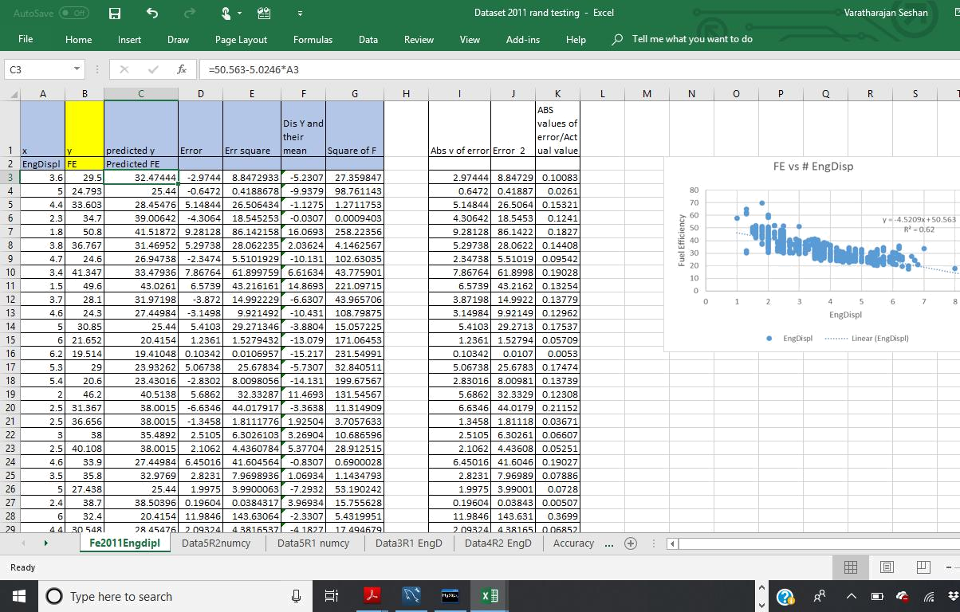

Use Excel Data Analysis tool
- Use Data Analysis feature of Excel to bypass the co-efficient calculation formulas and compute the Regression Model directly.

- You should be able to repeat all the points asked under “Use Excel” using Data Analysis tool. You may need to do the random sampling separately here as well.
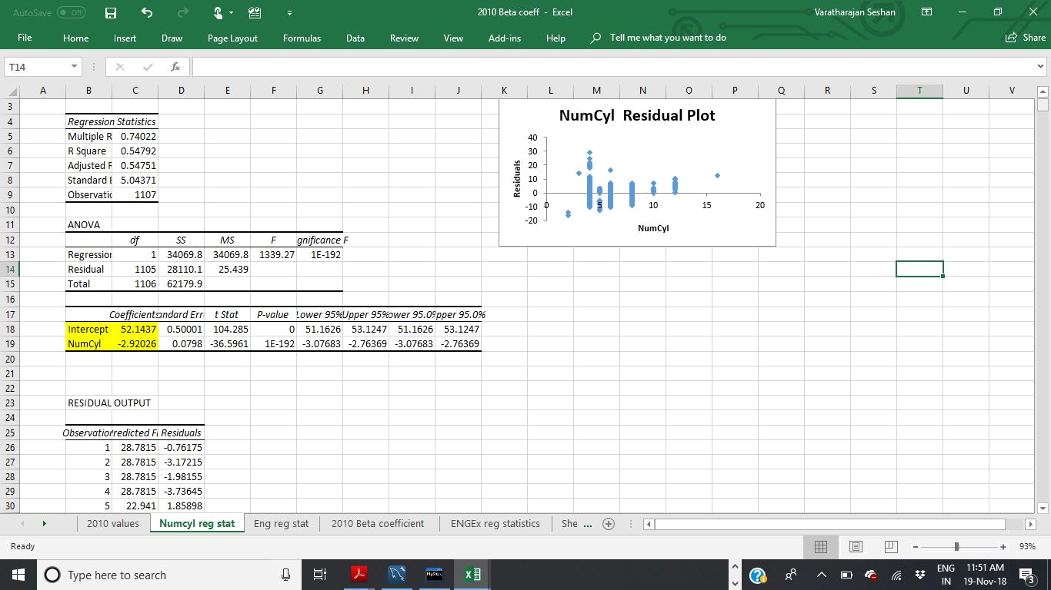
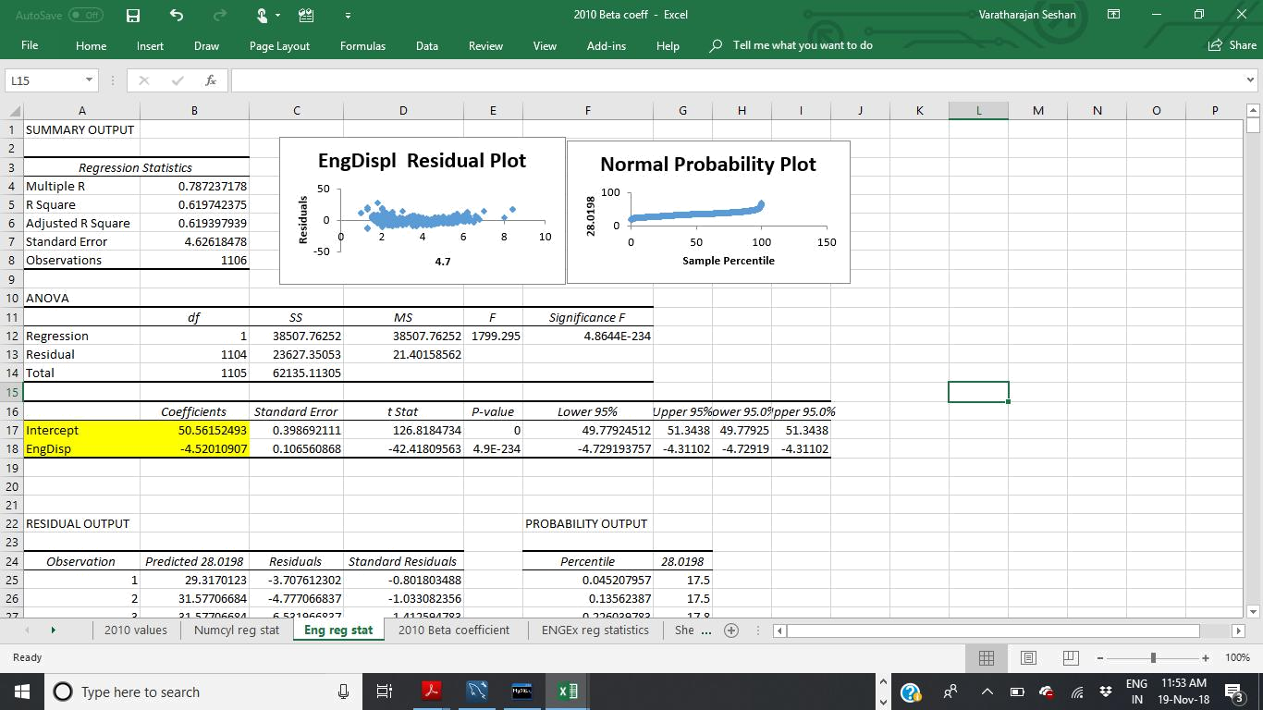
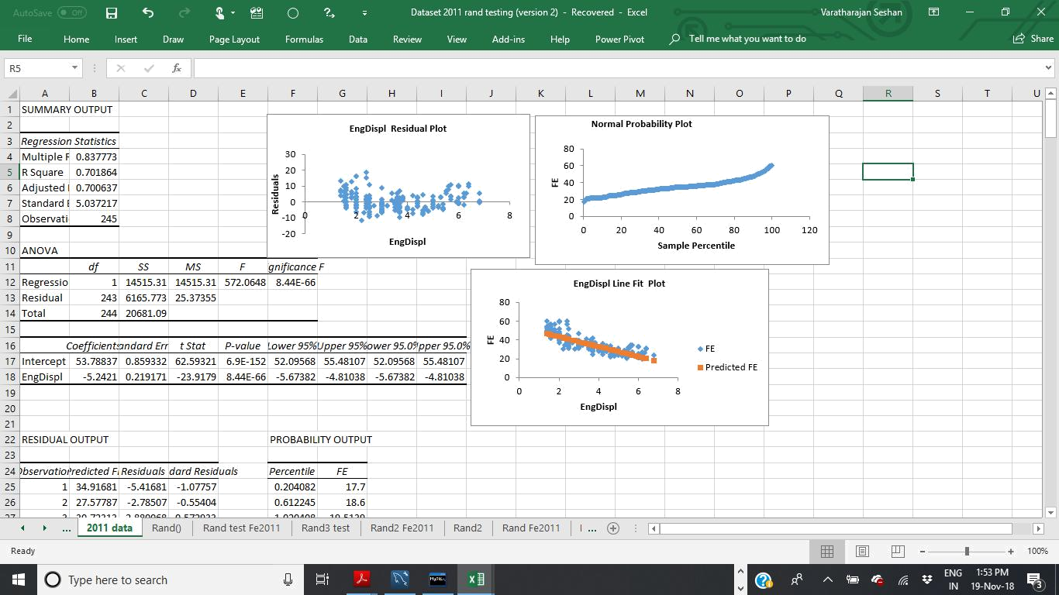
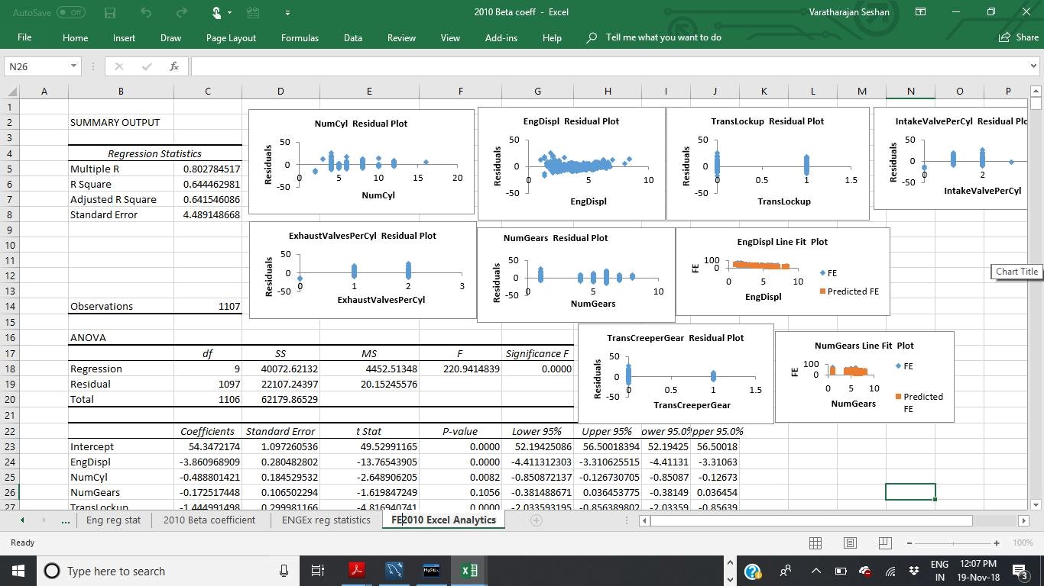
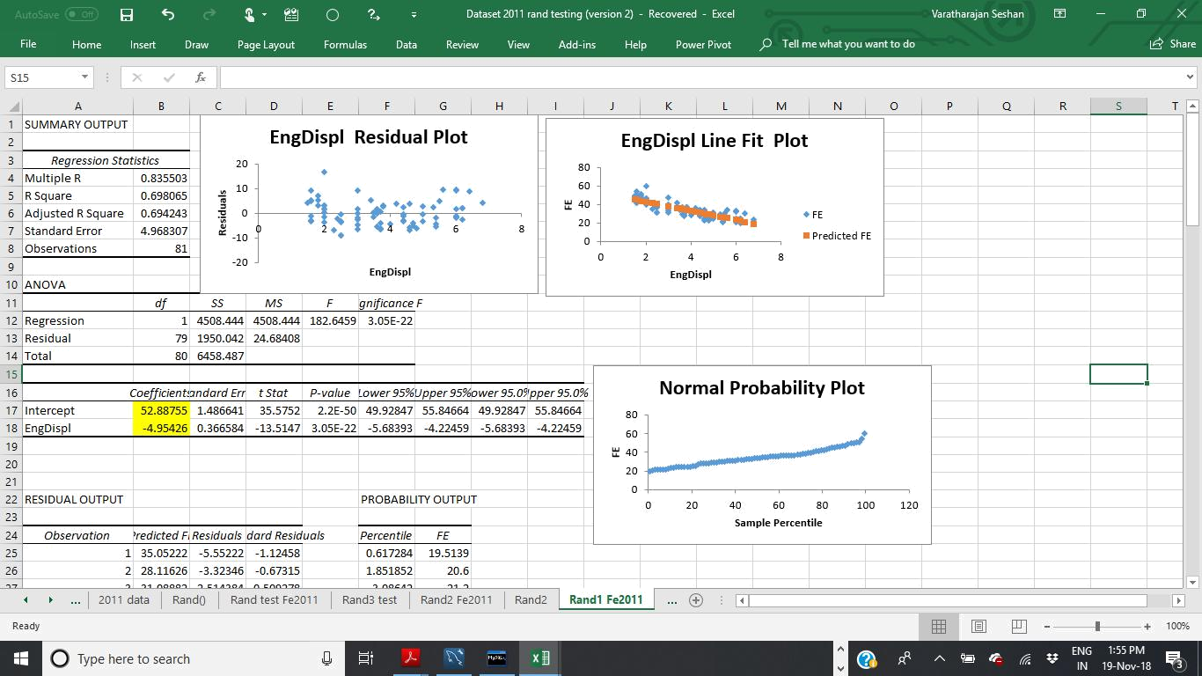
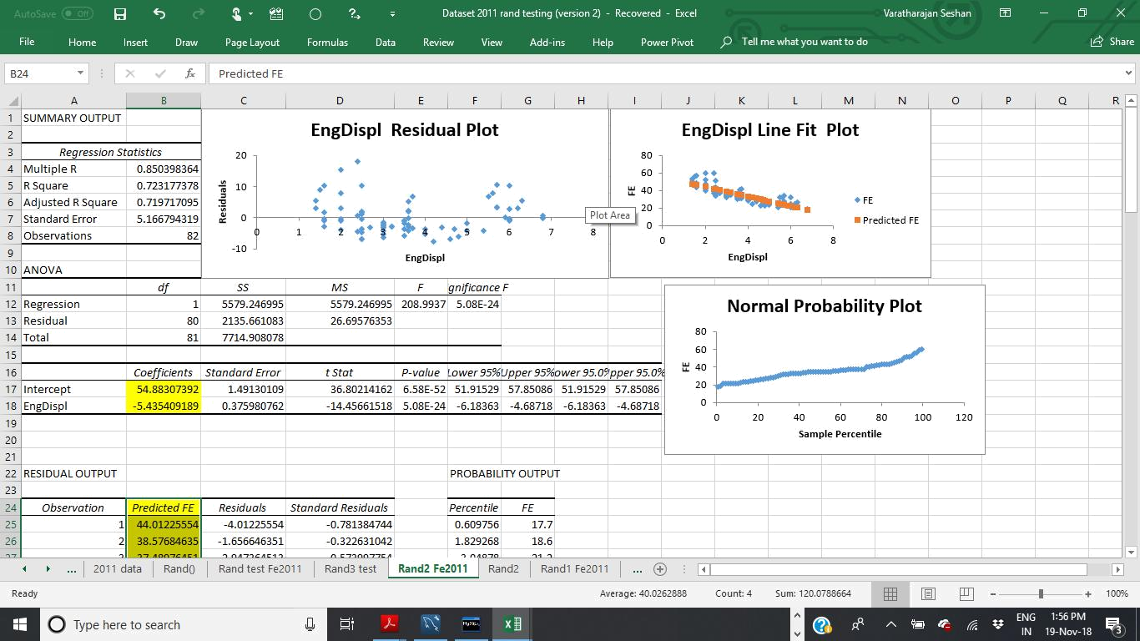
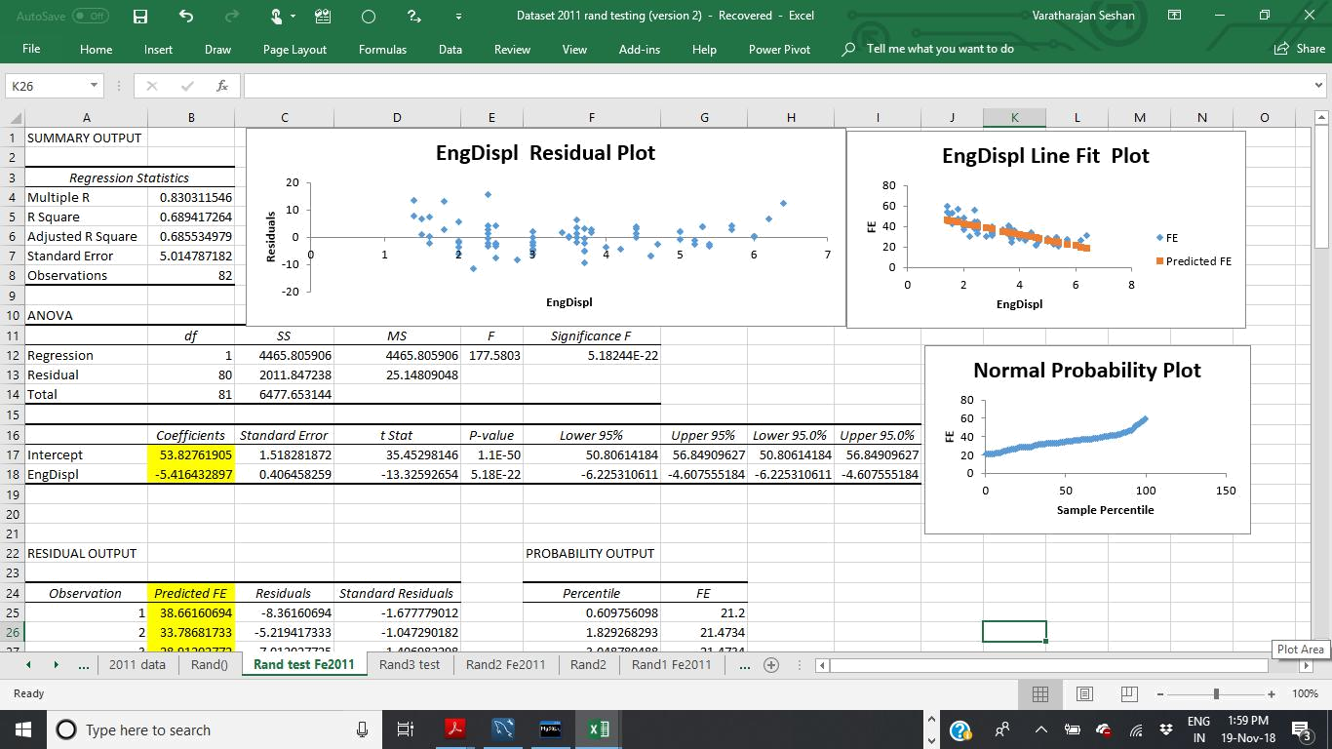
Use MySQL
- Upload the 2010 and 2011 dataset into a MySQL database named “fuel_economy”. The table name should be “fe2010” and “fe2011” respectively.

- You have already calculated the beta coefficients for the full 2010 dataset. Insert two additional columns for the beta coefficients in the “fe2010” table

and populate the columns with beta values. You can just take the previously calculate beta values to populate here. Remember the beta values will be constant

for each column here.

- Once point 10. is done, Calculate the Predicted value for “feb2011” table by using the input variable from “feb2011” and beta coefficients from “feb2010” table.
Insert the predicted values in an additional column in table “feb2010”.

My SQL Part is submitted separately as MYSQL submission for Project 1.1 as part 2

Acknowledgement

This is a quite interesting project and I have gained a lot of knowledge about Excel analytics, MYSQL and finding the linear relationship in R, Excel graphs are very much interesting. I thank the institute Acadgild and the Mentors Mr. Mohit & Ms. Puja who taught us the R Excel, MYSQL and other subjects to understand the Analytics. I once again thank Acadgild for enlighten me on Machine learning through online teaching and various coding support through the support coordinators. Thank you Acadgild.

